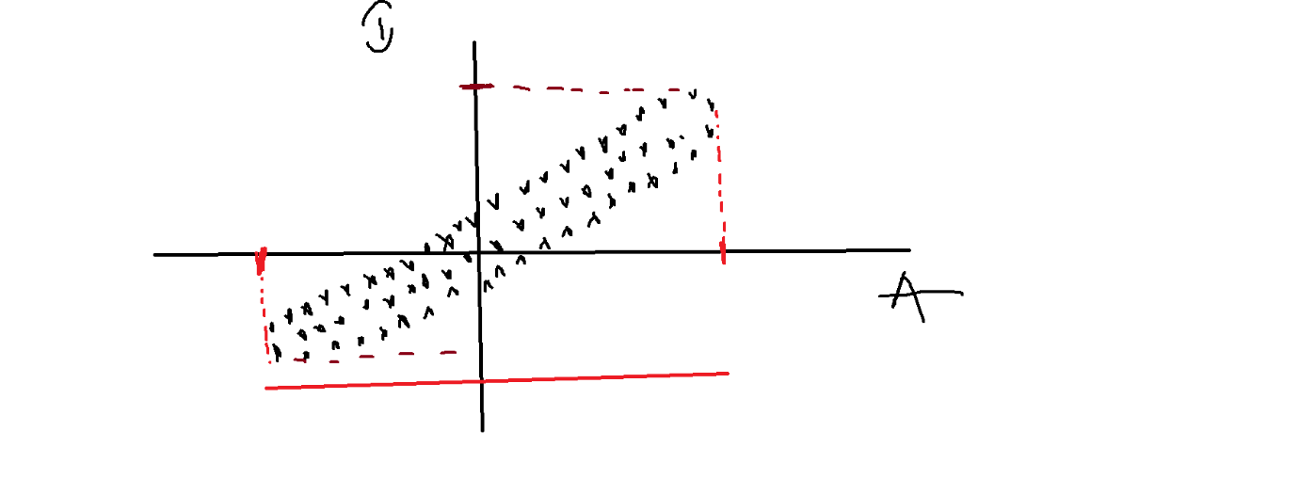

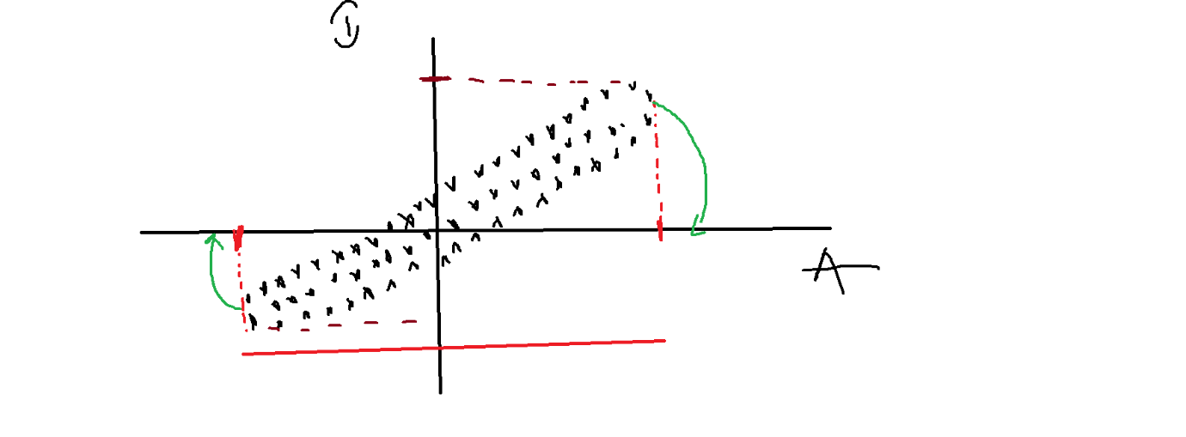

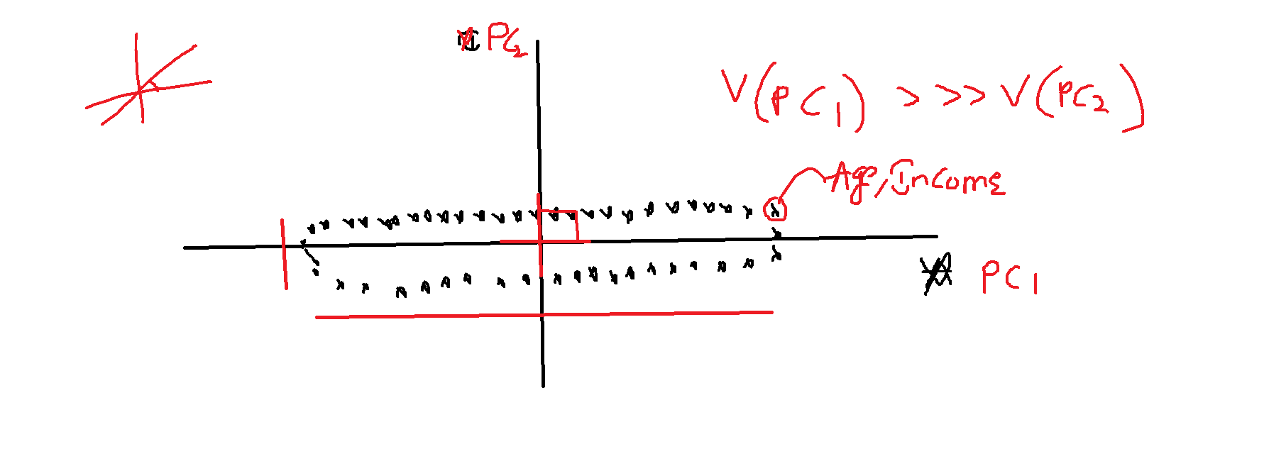

1) when a data point is changing

towards to another direction

means data value change

New data = olddata \* vector

2) Vectors will say to my data points

A) Go in that direction

B) Go some amount of duration

3) This duration is nothing but data travel

along that direction

direction means new axis

travel means=variance

data = olddata\*vector